Tail Light
28th Jan, 2026
Questions from Team:
1. The prototype requires three 12 V input signals for the brake, left turn, and right turn lights. Each signal is converted to 3.3 V using three ICs (buck converter) before being read by the microcontroller, requiring three input interface circuits in total.

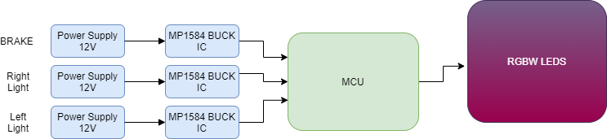

2. Put three switches (brake, turning left or right) to MCU. When each switch is pressed MCU will perform its function on RGBW leds.

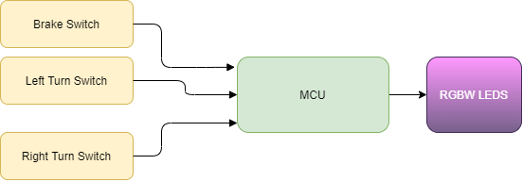

3.When the car is moving and no brake or turn signals are applied, the red LEDs remain dimmed at 40%. When the car is stationary, RGBW LEDs are enabled and controlled through the mobile application. But for these conditions (running or stationary) the MCU cannot sense vehicle movement directly, a separate signal or condition is needed to identify the stationary state or movement state.

4. Are we also using RGBW LEDs for brakes, turning and Running signal. And RGBW LEDs like ws2812B don’t need driver IC. 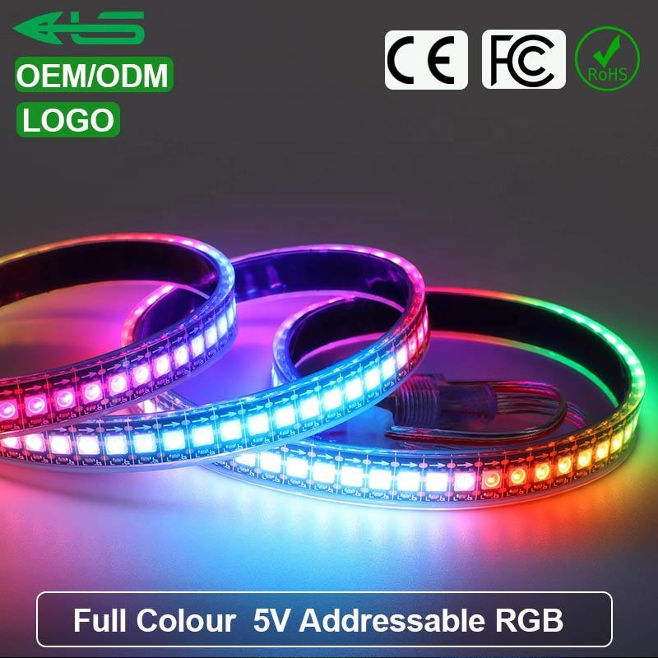
This has built in driver IC. And for brakes and turning both it can be used . And for app control it can be used as well. So in conclusion for both priority based lighting logic (Brake,Turn,Running), and robust Bluetooth-enabled RGBW control we can use one single RGBW strip.

